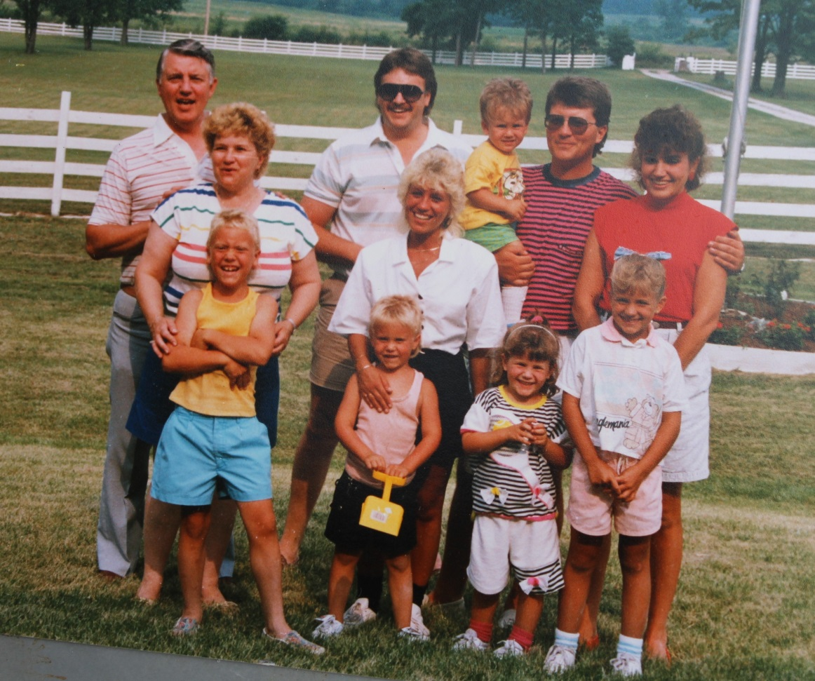

**Back row: David Wolfe List, David Allen Link, Joshua David List, David John List**

**Middle row: Carolyn Huffer List, Ann List Link, Nancy Kramer List**

**Front row: Jeremy David Link, Tyler Jay Link, Natalie Marie List, Amanda Leigh List – 1985**



**Jeremy David Link - 1999**